1. ***Distinct customers: (page 5)***

DistinctCount- can be applied at column level not at table level.

Go to Important Measure table and add new measure: 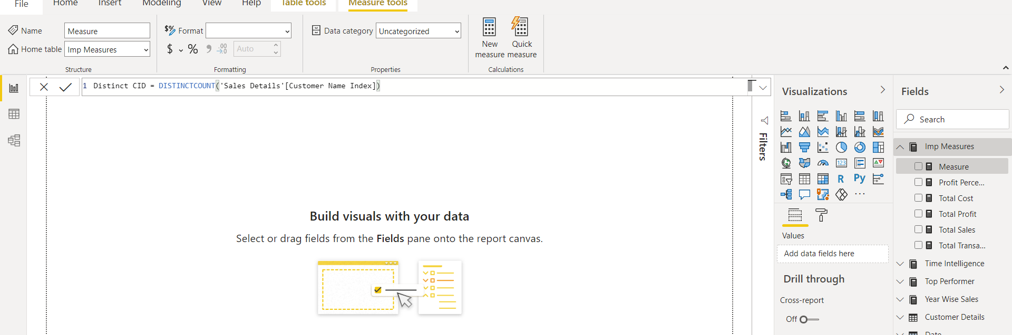

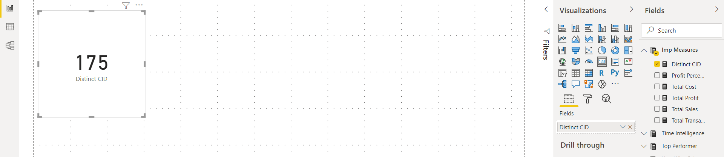

1. ***Calculate sales in terms of season***

There are no details with respect to the season in the dataset. So, we need to understand sales details table.

There are 4 seasons mainly. So, we have to divide our data on the basis of these seasons or months.

* Summer – June to August
* Spring
* Winter
* Autumn

Create a new table: Seasonal Sales

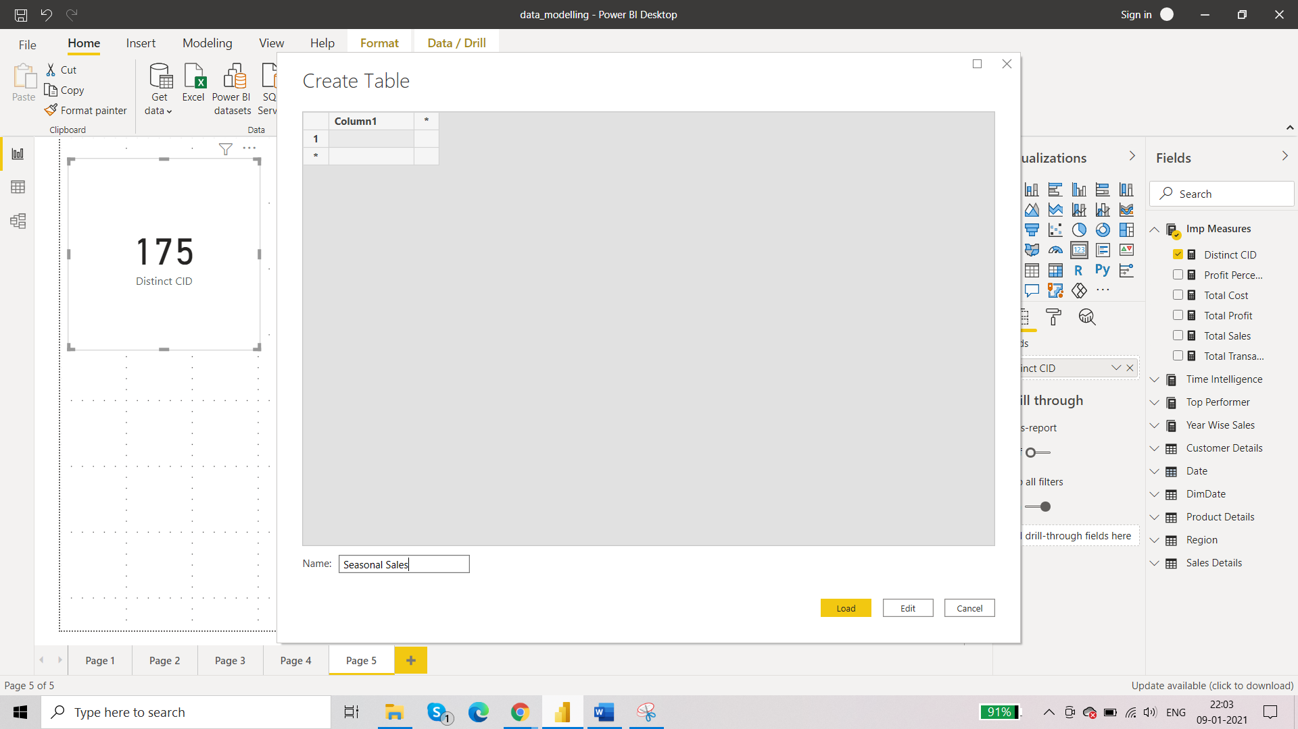

First, we will calculate seasonal sales for 2019. Create new measure:

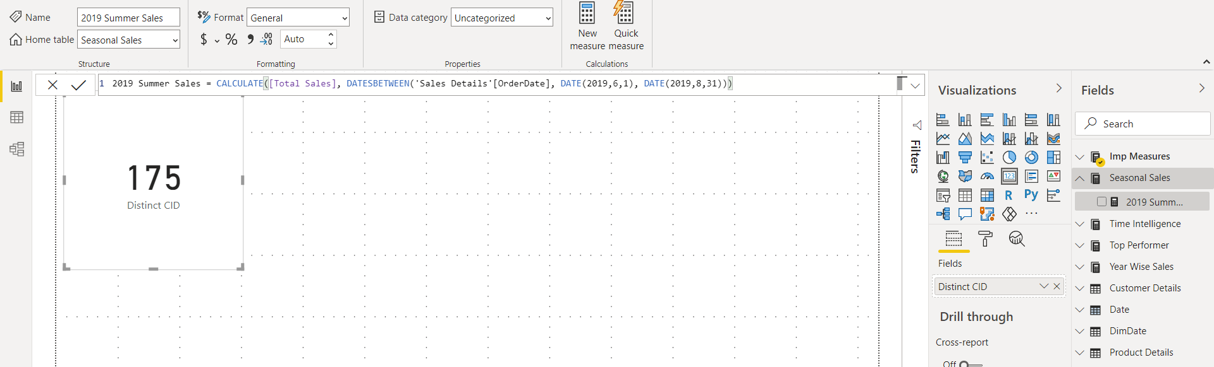

2019 Summer Sales = CALCULATE([Total Sales], DATESBETWEEN('Sales Details'[OrderDate], DATE(2019,6,1), DATE(2019,8,31)))

2019 Winter Sales = CALCULATE([Total Sales], DATESBETWEEN('Sales Details'[OrderDate], DATE(2019,12,1), DATE(2019,2,28)))

2019 Spring Sales = CALCULATE([Total Sales], DATESBETWEEN('Sales Details'[OrderDate], DATE(2019,3,1), DATE(2019,5,30)))

2019 Autumn Sales = CALCULATE([Total Sales], DATESBETWEEN('Sales Details'[OrderDate], DATE(2019,9,1), DATE(2019,11,31)))

1. ***What was the last purchase date? How many days have passed since the last purchase date?***

Since this has time factor. We will be creating this under Time Intelligence measure table.

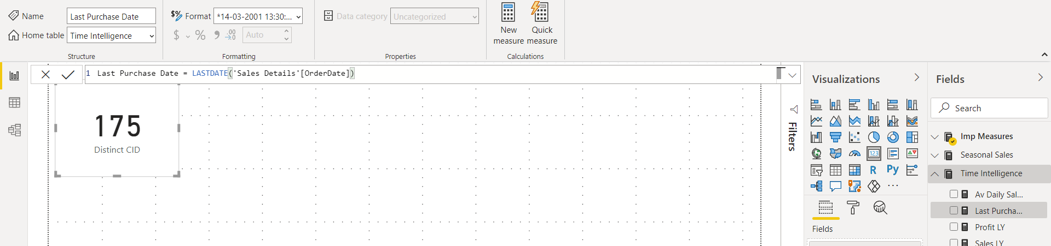

Now we will calculate number of days. Here we will use another measure for the calculation:

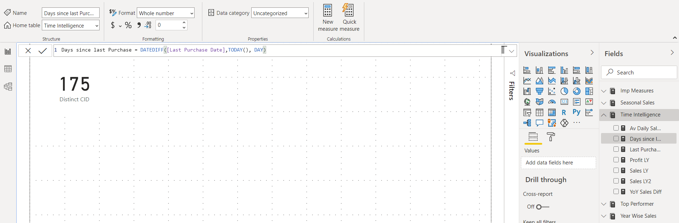

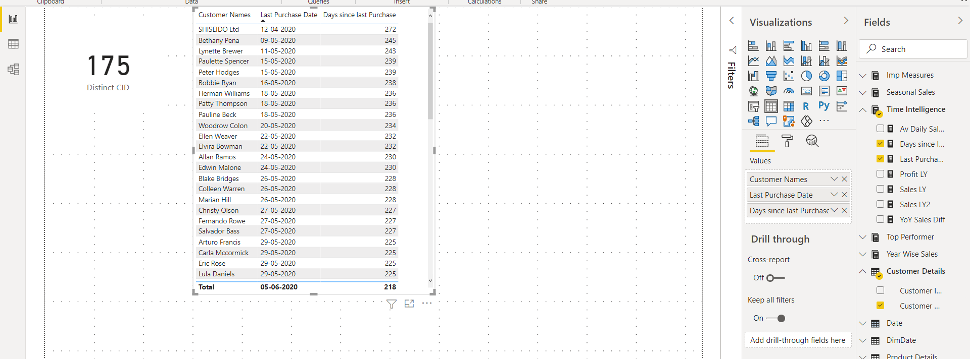

1. ***Instead of creating measures, we want to add some info to the existing data***

Case 1: in customer details table, we want to add last purchase date as a column for each customer.

Add a new columns from data view.

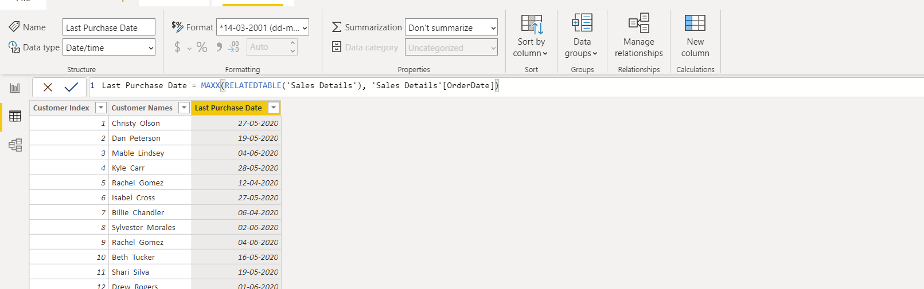

Case 2: add total sales for each product then segment those sales in terms of low and high

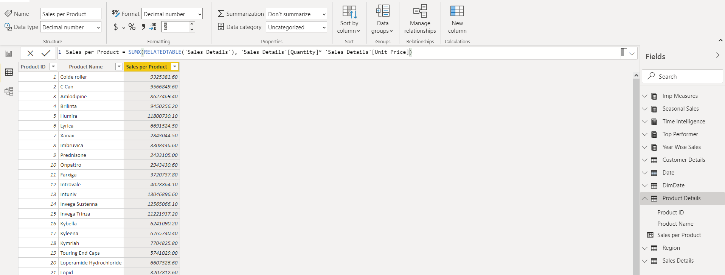

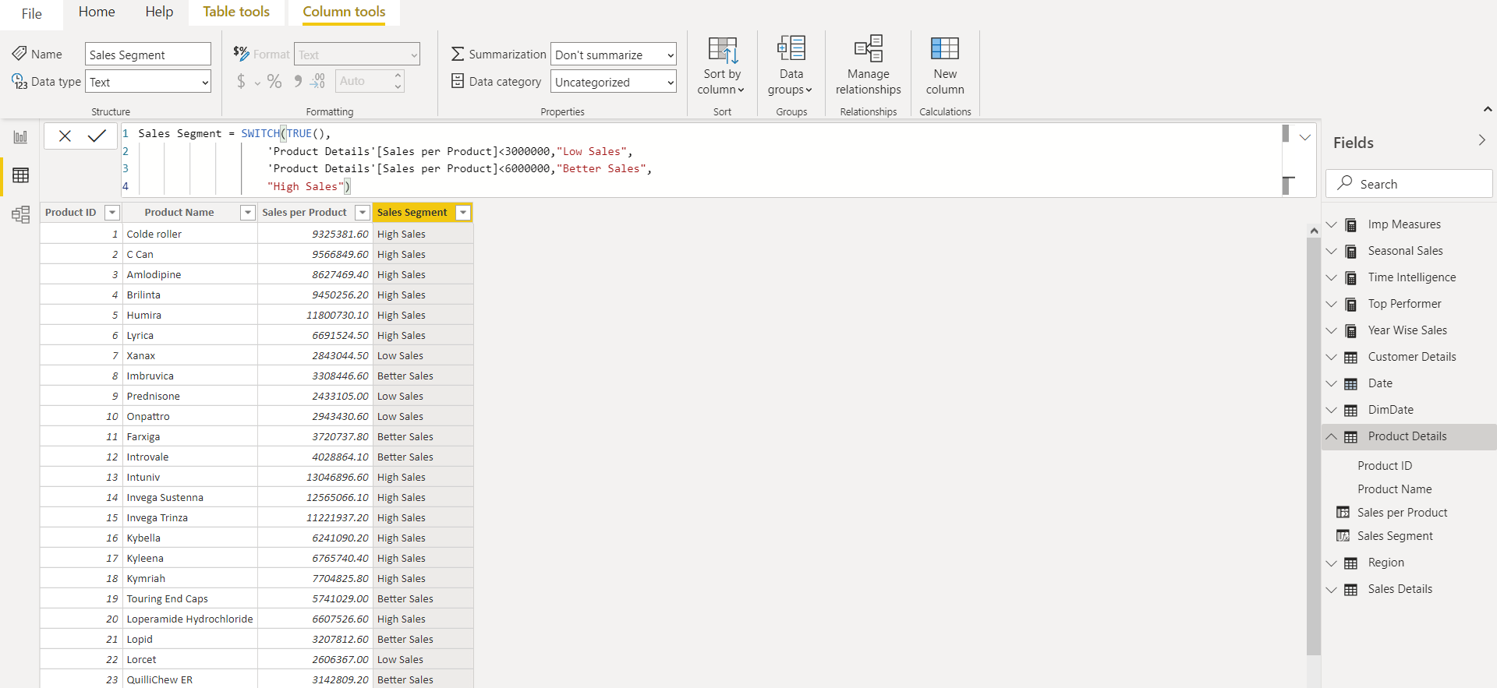

1. ***Last N days of Sales (Page 6)***

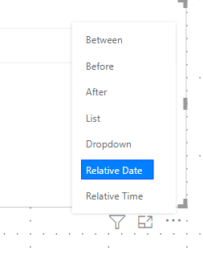

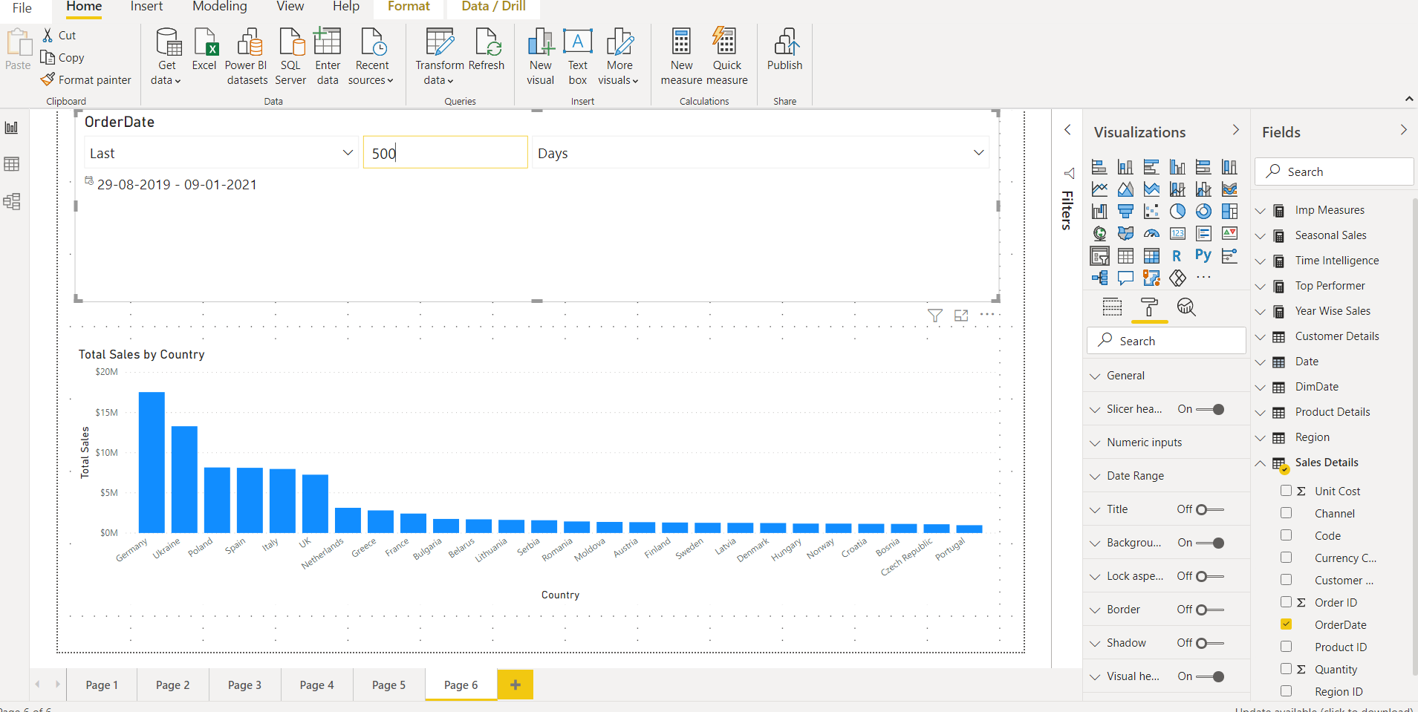

1. ***New Quick Measure * not advisable: total sales***

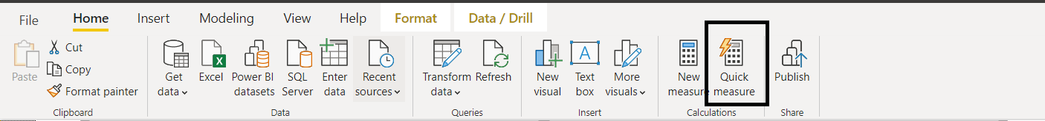

Page 7

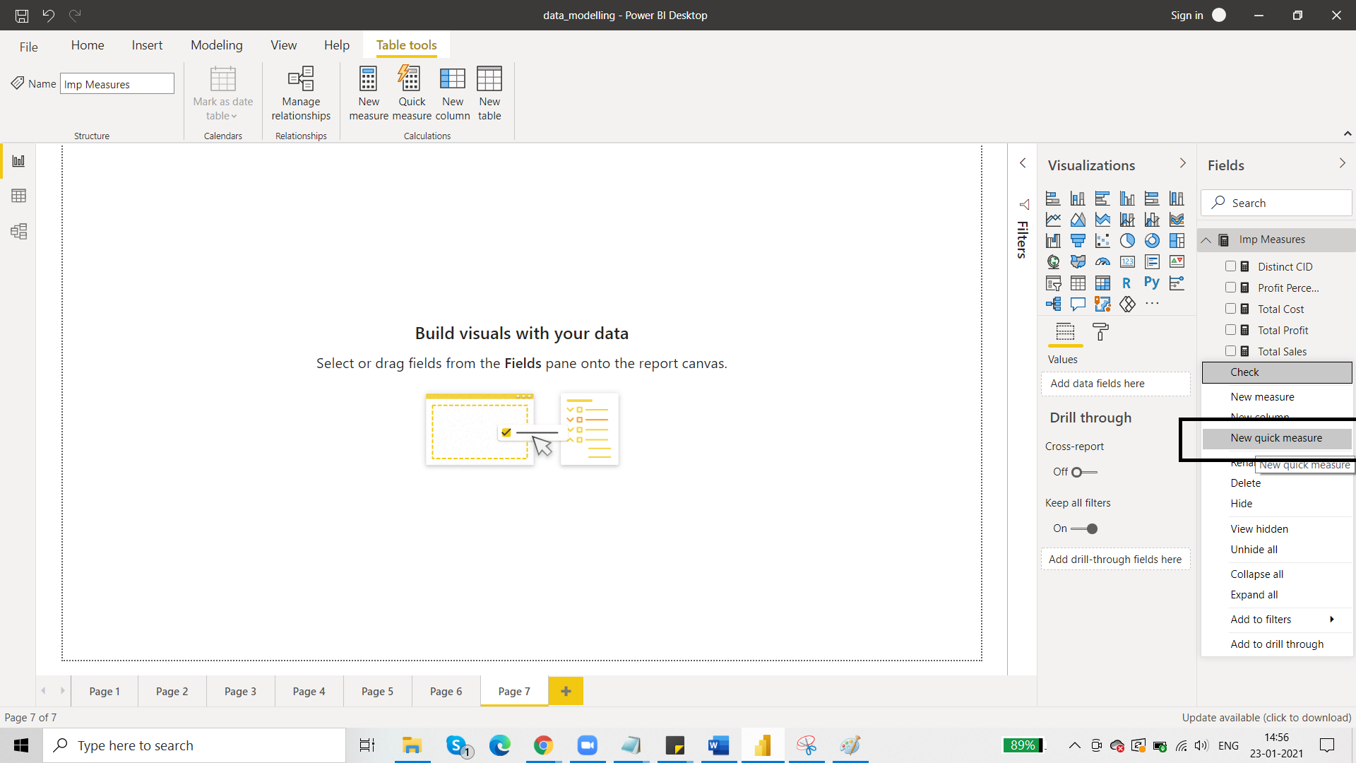

Requirement : sales for a specific country in terms of Total Sales measure

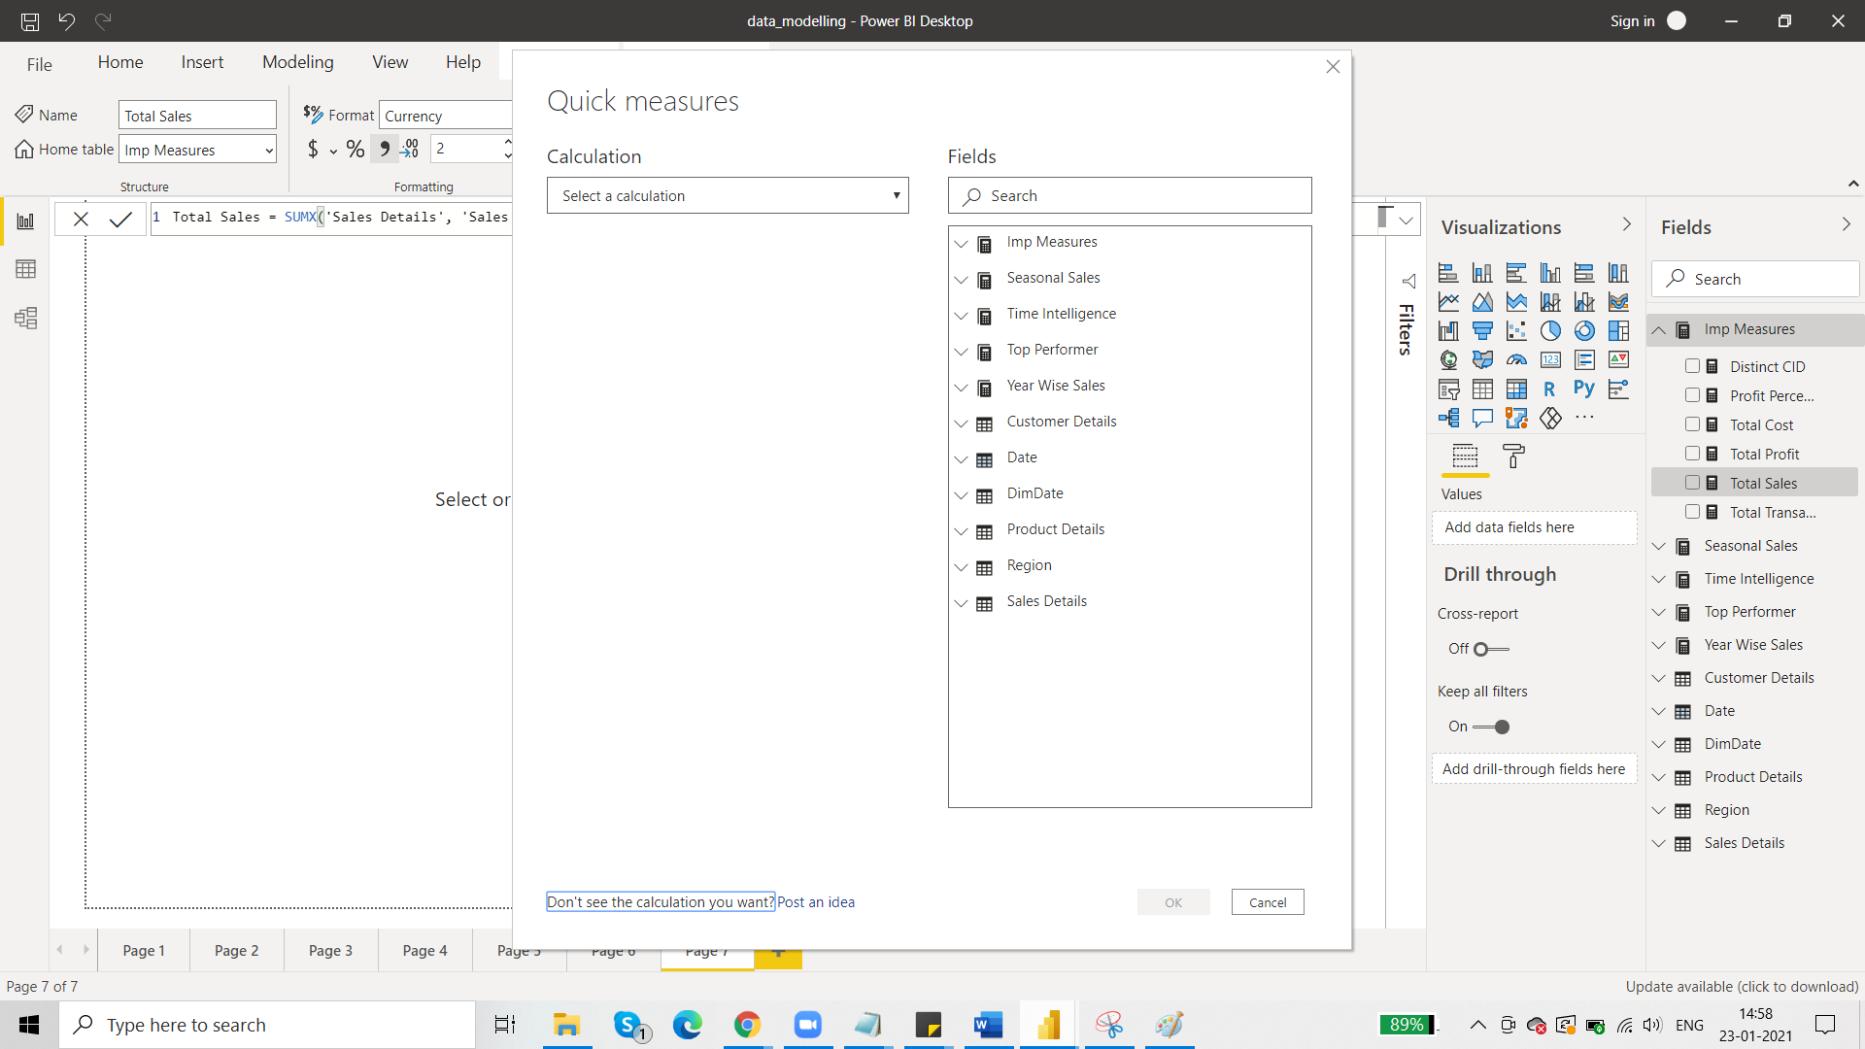

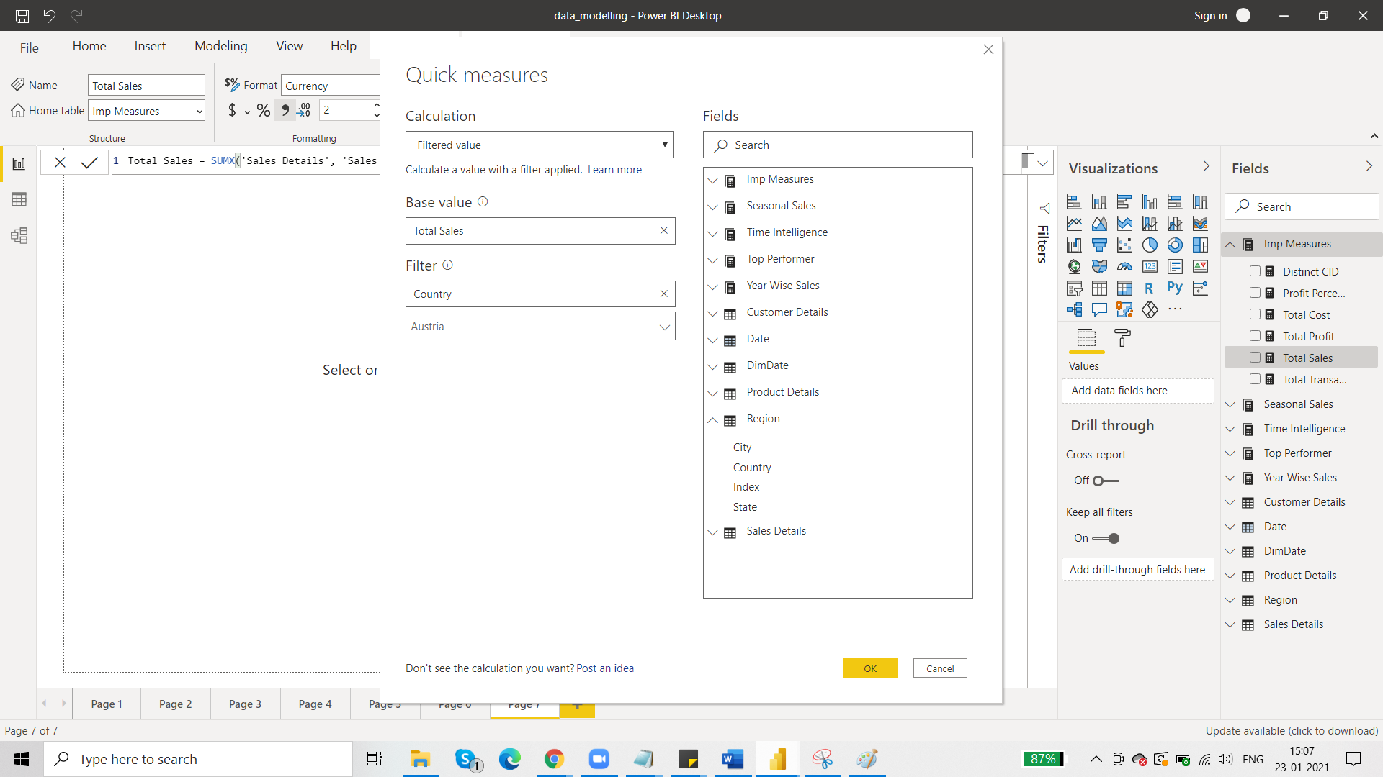

Then click ok and you will get a new quick measure on total sales:

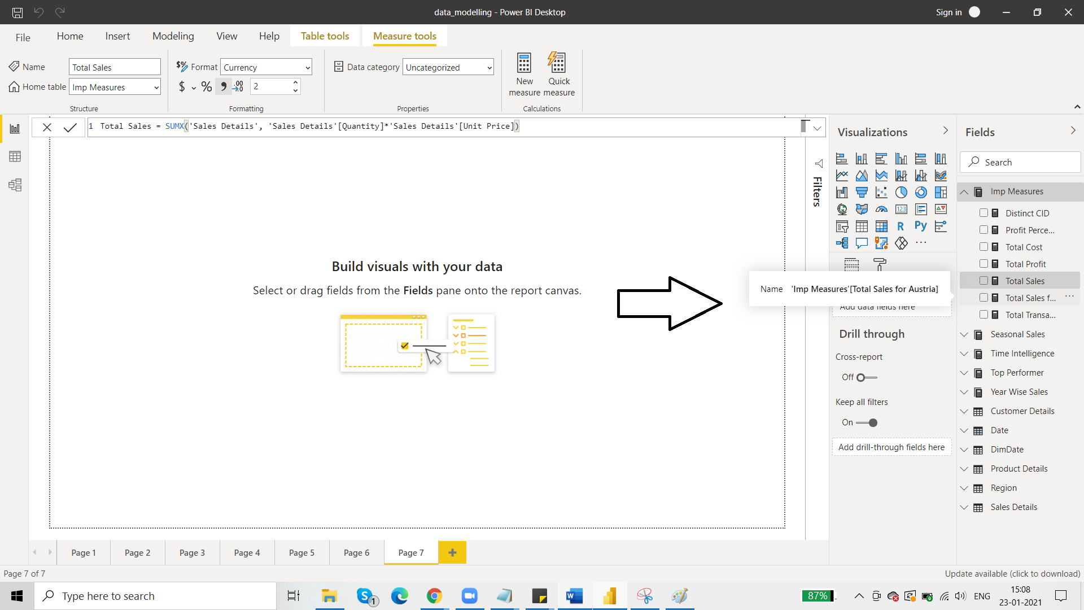

So you don’t have to write a single code of DAX to produce this and that is why it is dangerous because you not come to know DAX code in case anything comes wrong or you want to analyse the code. You need to have a very good hold over DAX to use quick measures.

1. ***New Quick Measure : total profit***

Requirement: we want to know YTD profit.

So, time means we have to go to time intelligence table.

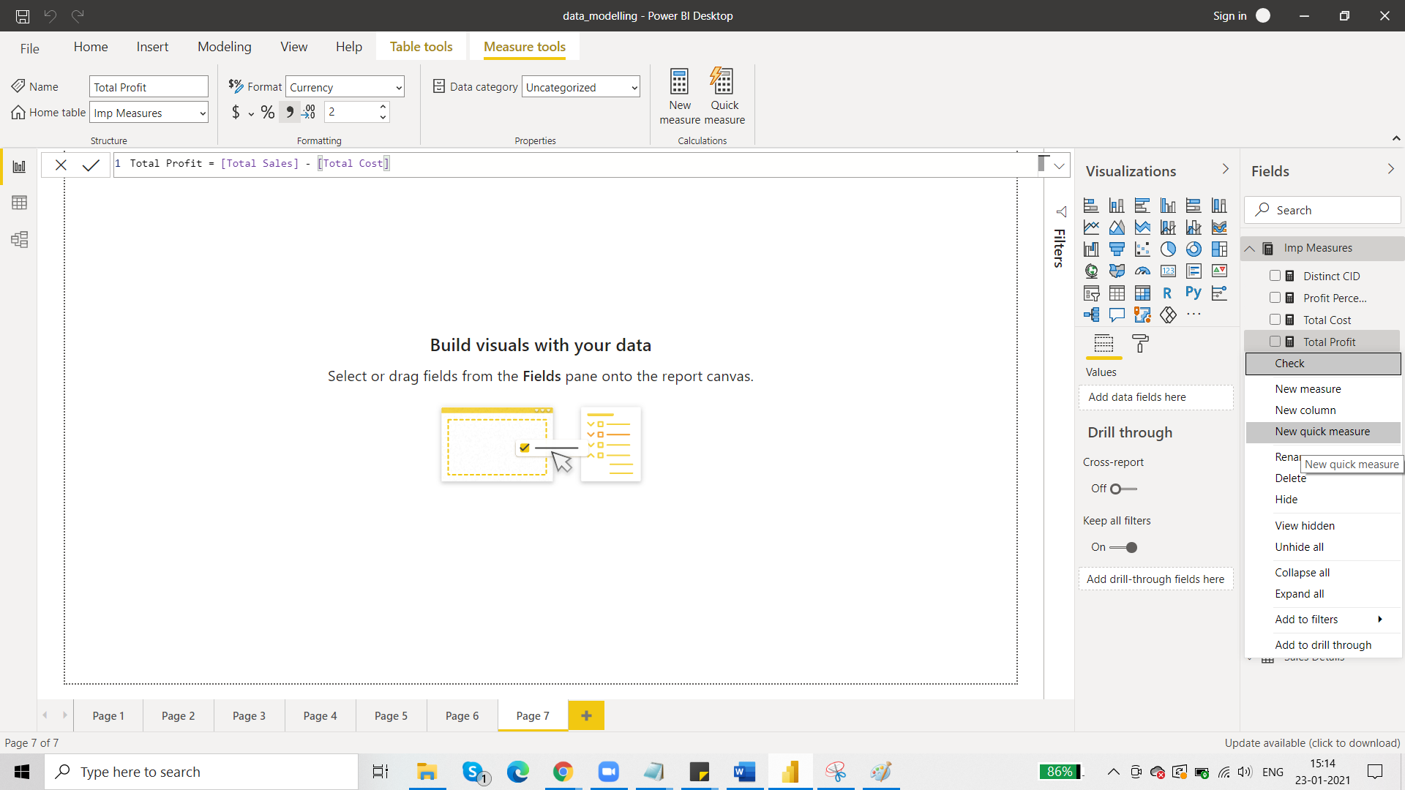

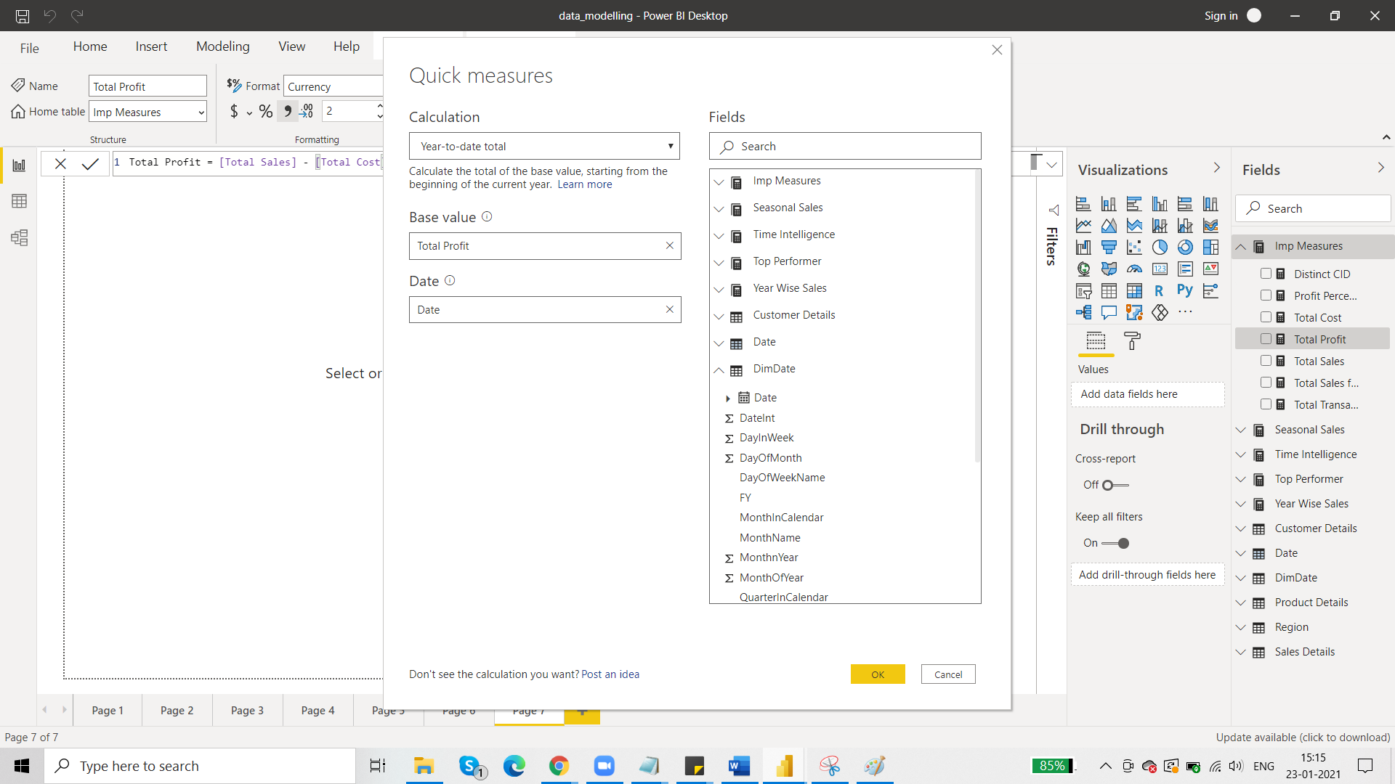

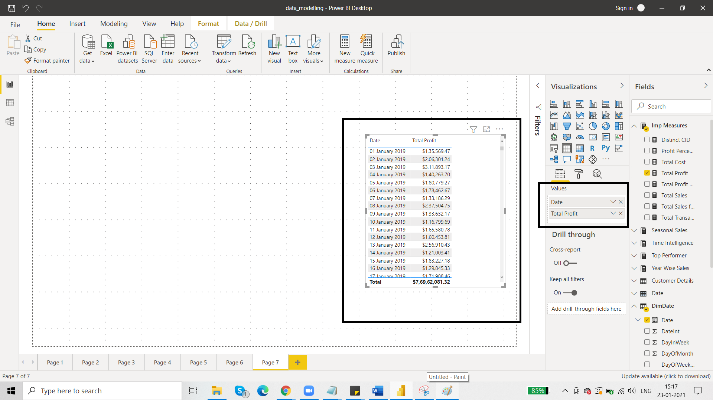then we try to put Total Profit YTD:

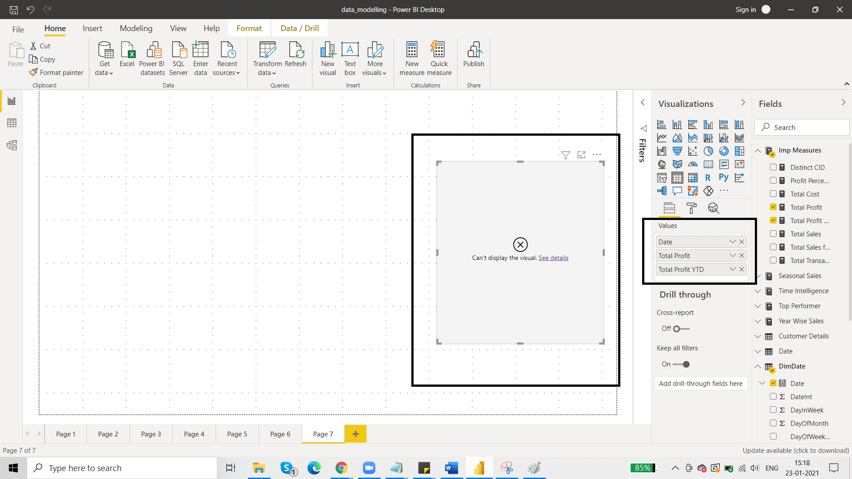

The visual throws an error. This is because of the date format. Whenever a measure is created as result of quick measure then it supports a particular date format i.e. date format with hierarchy.

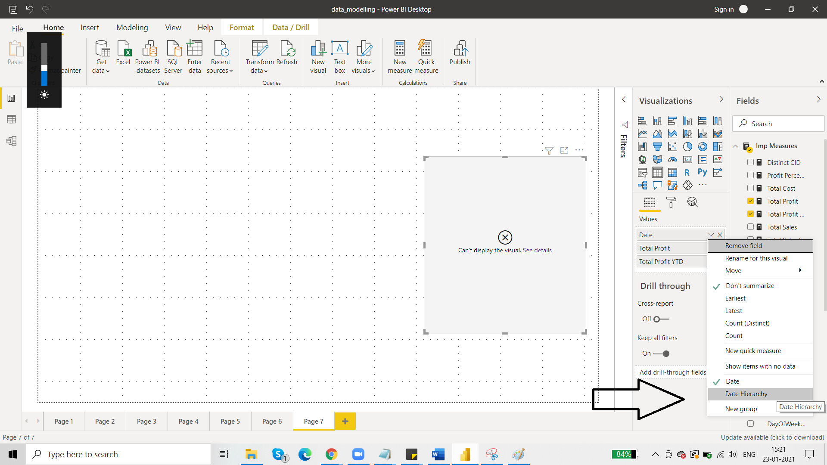

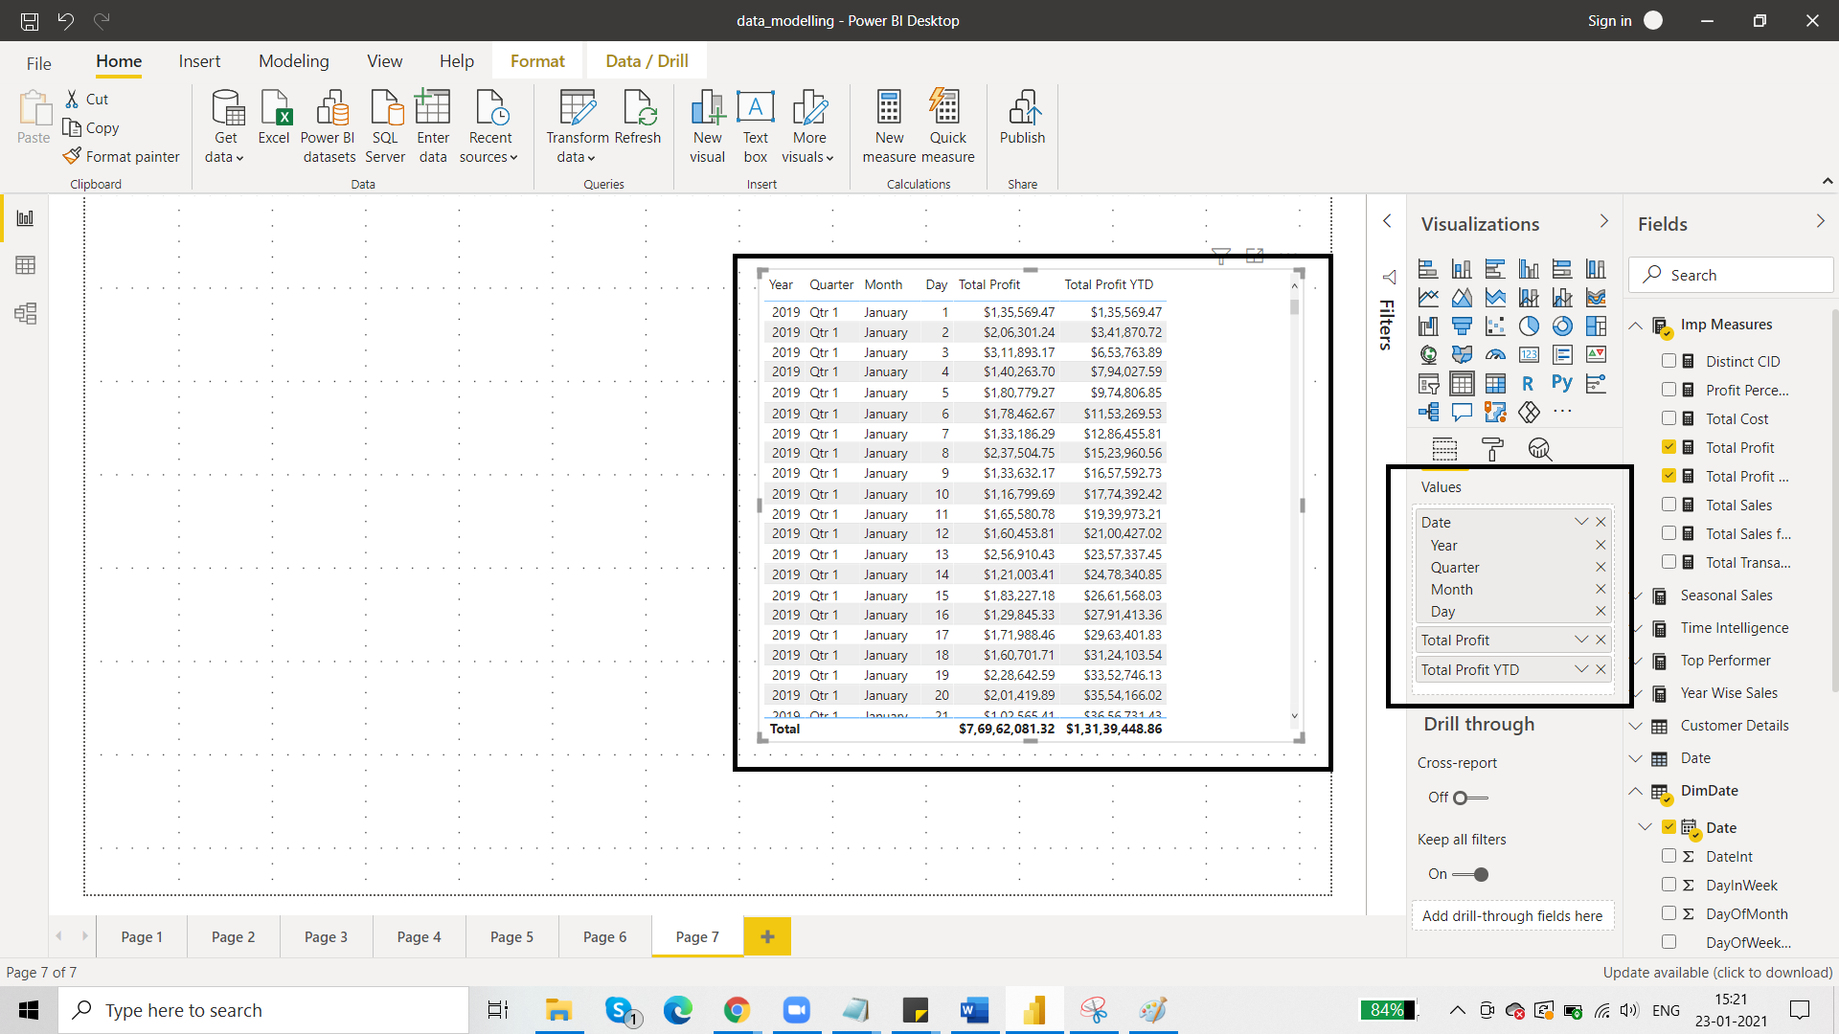

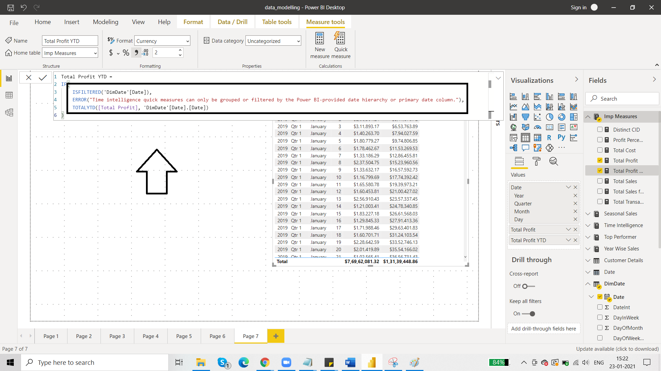

1. ***New table using DAX***

We created dimension table using DAX by using the calendar function. Now we are going to create table using DAX that is going to be the fact table.

Data model there is only one fact table: sales details

Suppose we want another table from this sales detail table. A table showing sales details for country Germany. This can be done on the basis of Region Id that we have in the Sales Details table.

So, we will create another fact table from existing fact table. But the new fact table is going to be a user defined table.

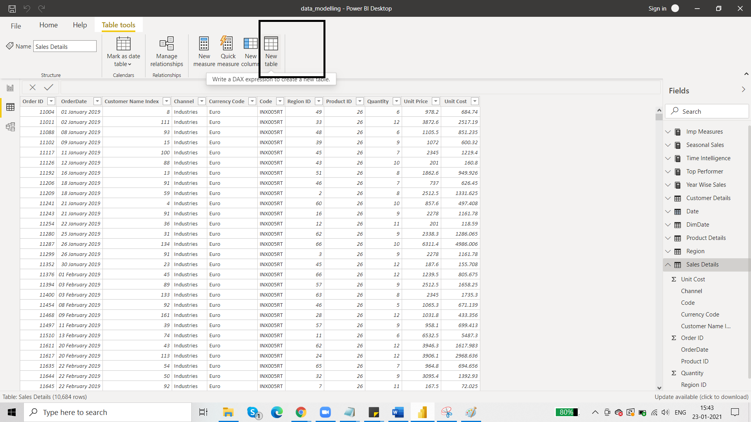

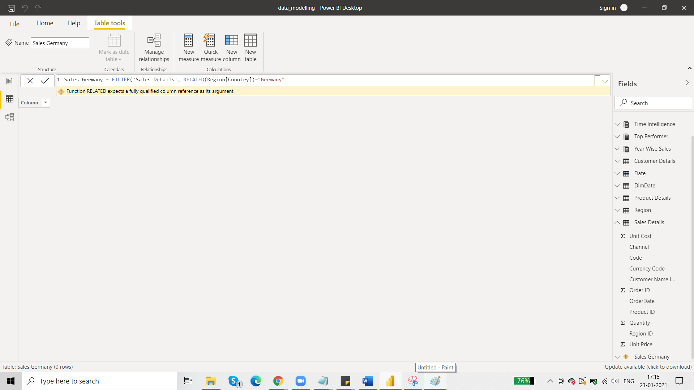

Click enter and table is created. 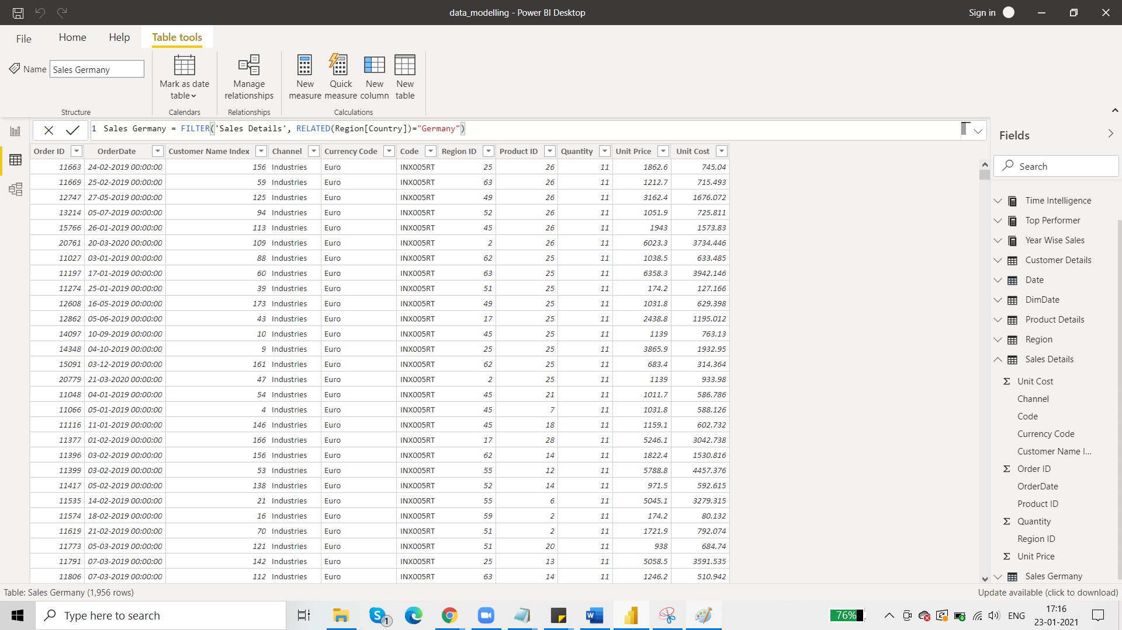

But we must also contain some column that identifies Germany. So, go to new column.

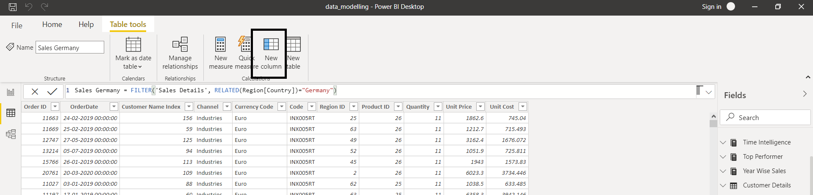

For adding a column here, we will need data from other tables like Region[country]. So for this to happen, we need to establish relationships.

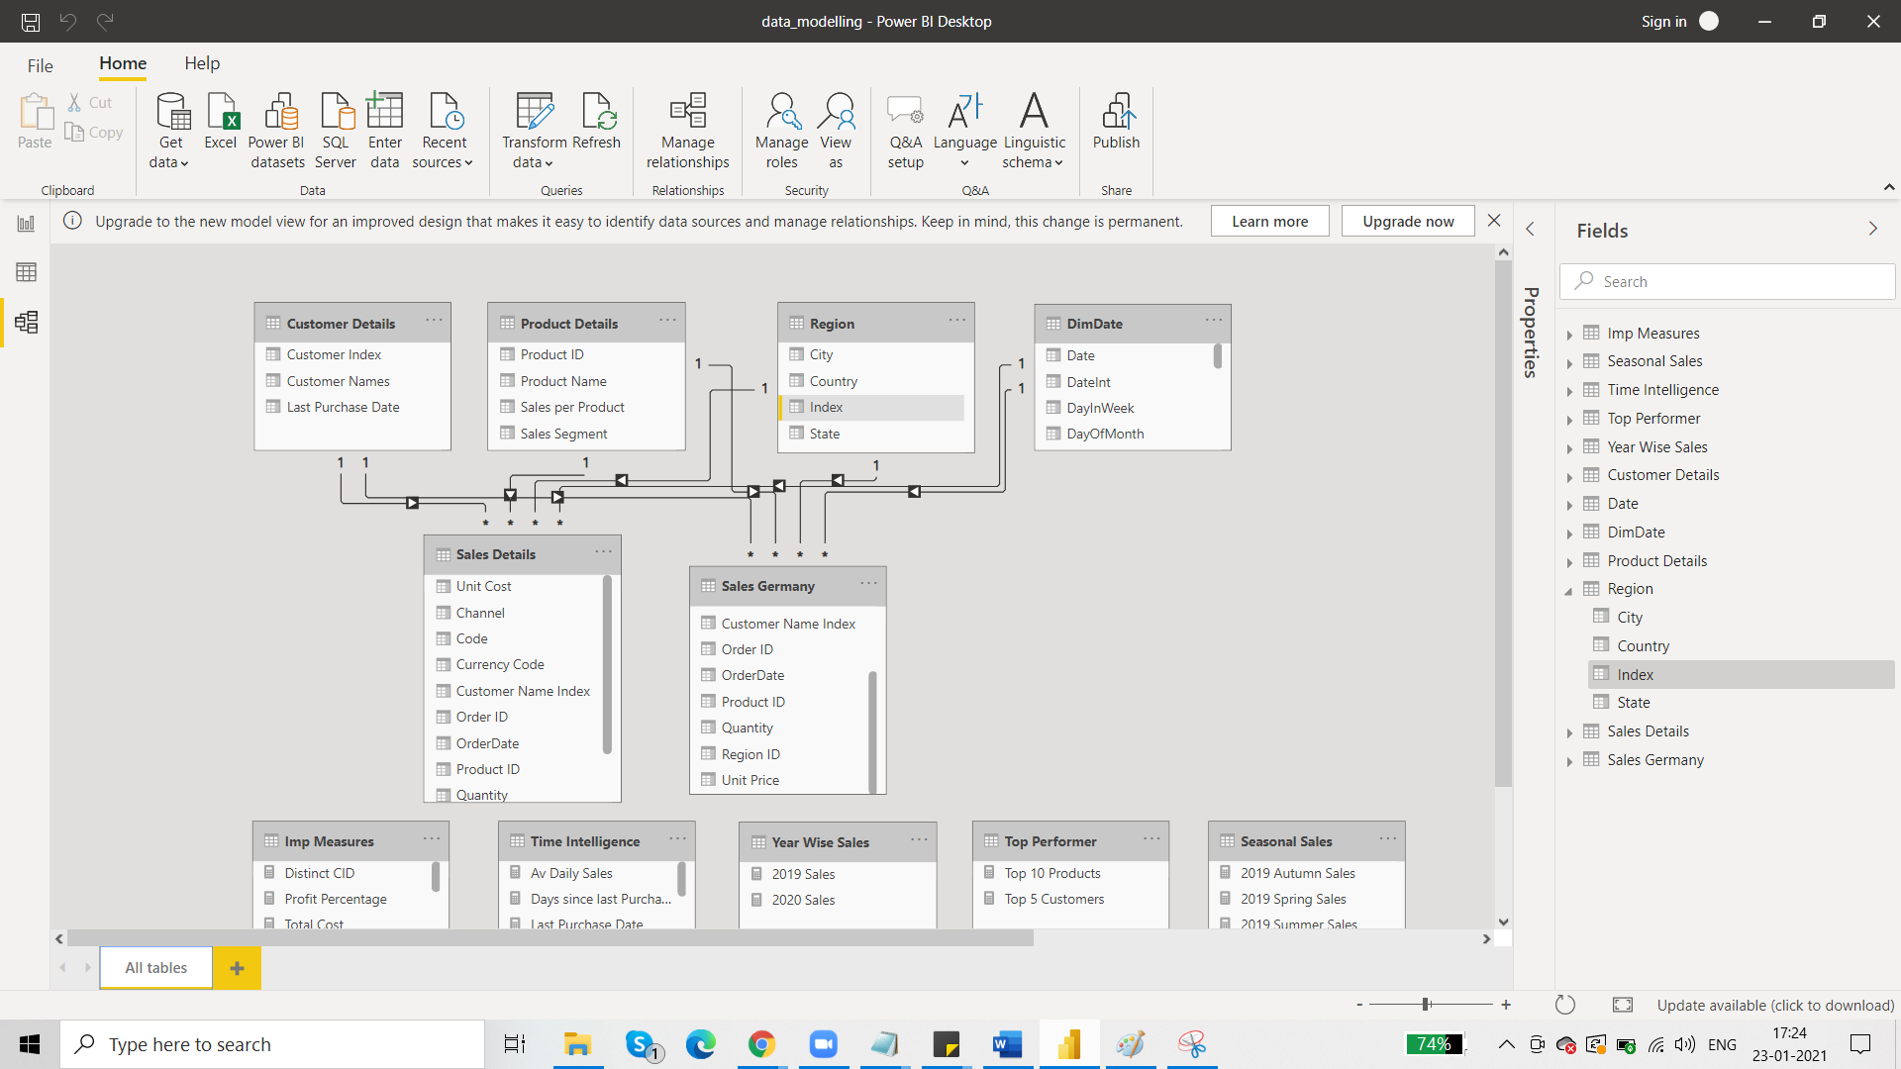

After this, add the new column:

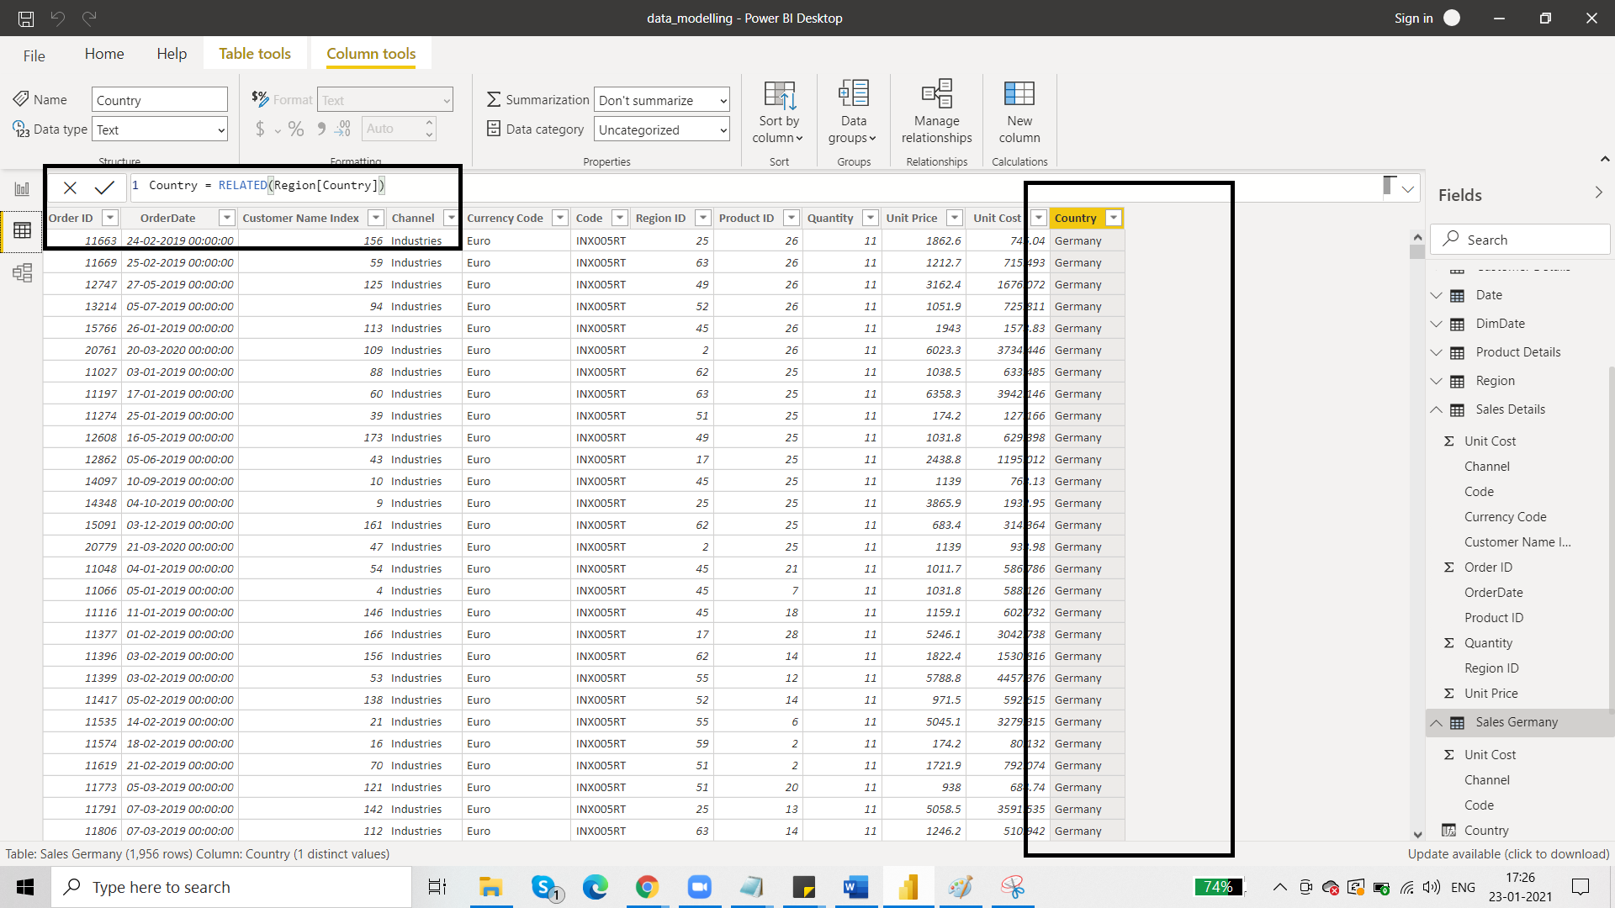

Now we can use this table in reports too. The colour of the icon of this table (table crated from DAX) is a little dark as compared to other tables.

***HOW TO WORK WITH SINGLE VALUE PARAMTERS:***

***DESIGN A FEEDBACK SYSTEM:***

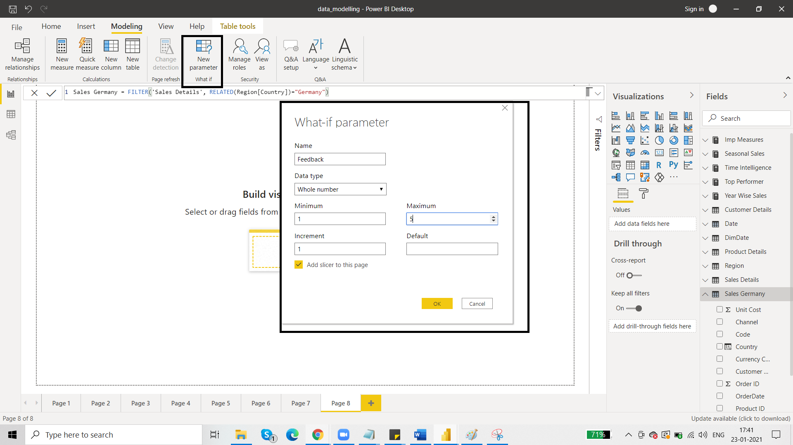

Page 8:

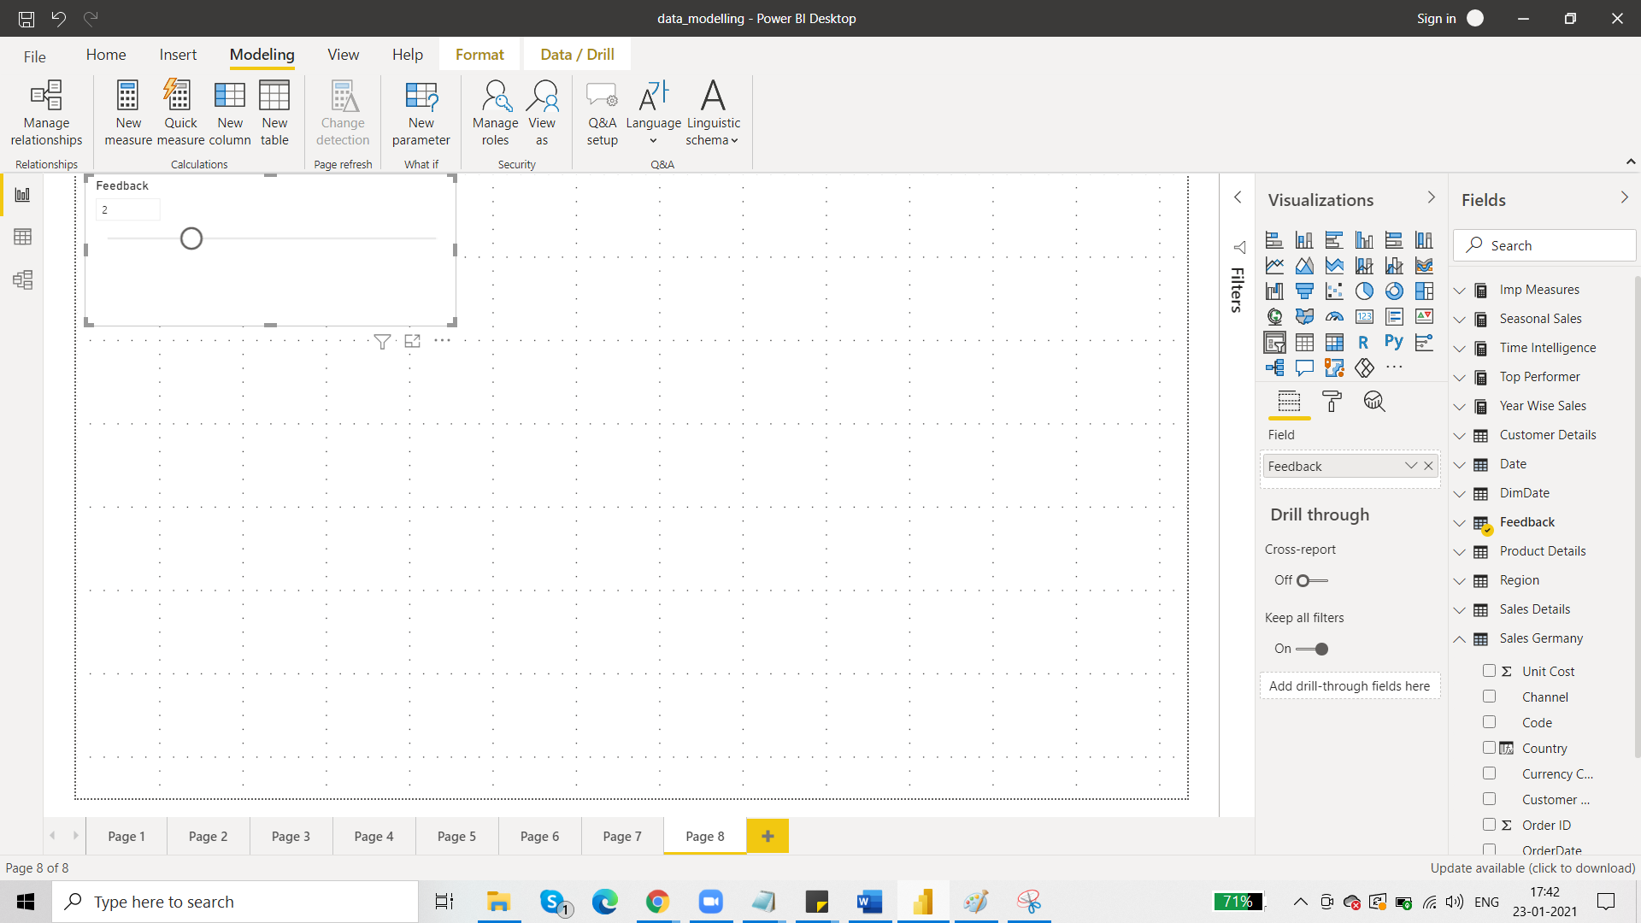

Add New Column:

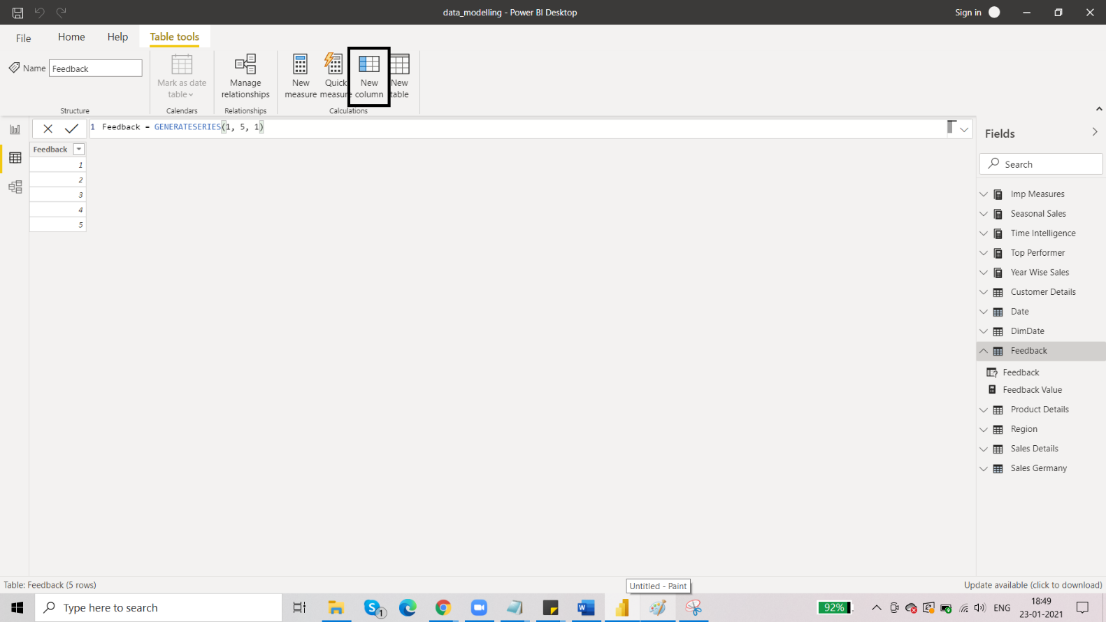

You can add emoji by windows and full stop key:

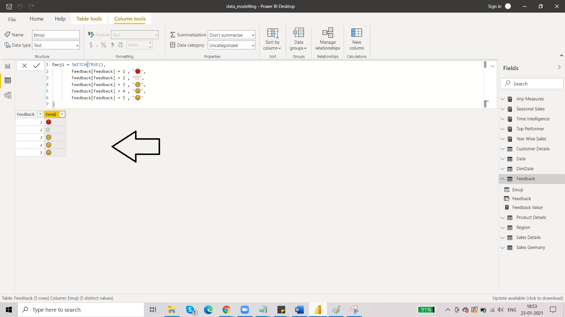we can use the emoji in the report by using a card:

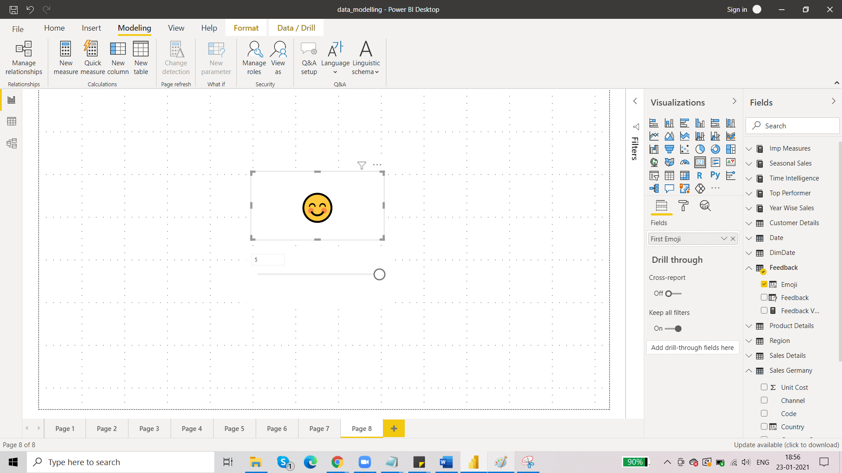

Dashboard is made on page 08.